

Portable SDR HF Transceiver



XIEGU

###### Ver. 1.6

Oper at i on manua I

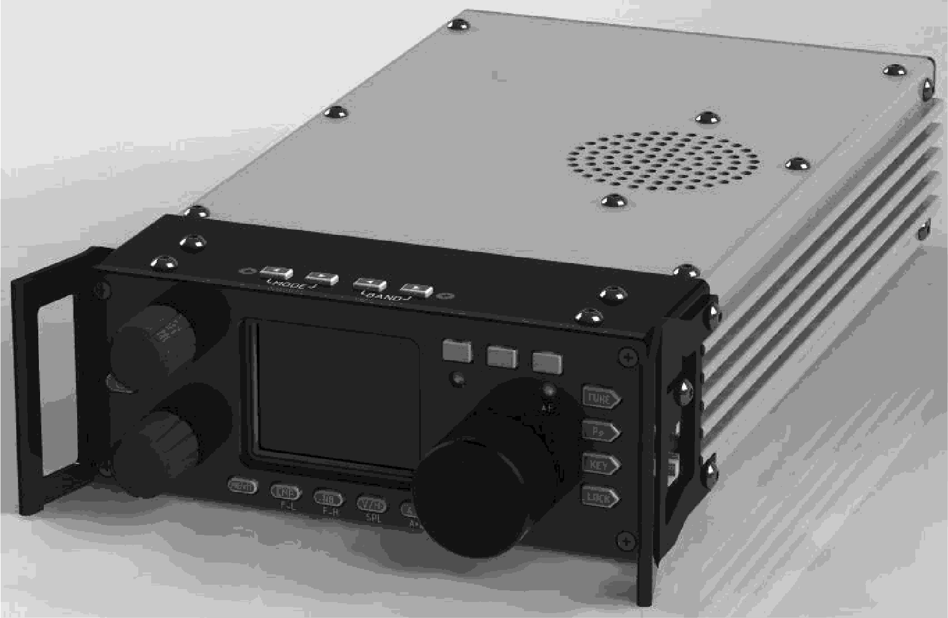

Built-in automatic antenna tuner ATU

**G - 90 – User Manual**

Edition 1.6 May,2019

Editor: John McClun [john@mcclun.com](mailto:john@mcclun.com)

A special thanks for Contributors: Wayne Tunstall, Fred Lesnick, Jon Illsey, Bob McLachlan, Thomas Ruhmann, Jasonn Pelligrini, Terence Taylor and all the members of the G-90 Facebook page for sharing your knowledge.

#### © Copyright Free for non-commercial use

Xiegu is a registered trademark of **Chongqing Xiegu Technology Co., Ltd**.

**Contents**

1. G-90 Description 5
2. Control Layout & Explanation 7
   1. Head Unit Connections 8
   2. Unit Rear Connections 10
   3. Quick Buttons Operation 11
3. Operating the G-90 Controls 15
   1. Operating frequency band selection 15

Set the operating frequency 17

* 1. Multi-function Knob Operation 19
  2. Adjust Transmitting Power Out 19
  3. Split VFO Mode 20
  4. Automatic Antenna Tuning Unit (ATU) Operation 21

Scanning SWR 23

1. Microphone Usage 24
   1. Using the Microphone to Control the Unit 25
2. Operating Mode 27
   1. Set up for CW Mode 27

Adjust Bandwidth 28

* 1. Operating SSB Communication 29

Set the Receiver bandwidth 29

To Enable VOX 30

3

* 1. To Enter and Recall Memory Channels 30
  2. Using Secondary (System) Menu 31
  3. Operating Digital Modes 32

Digital connections: 32

1. Wiring 34
   1. Connector Wiring Diagrams 35
2. Firmware 37
   1. G90 Firmware Update Instructions 39
3. Errata 47
   1. Boot interface call sign setting CSN 47

Addendum..(Digital Modes by Thomas Ruhmann)… 48

# 1 G-90 Description

Basic Features

G-90 is a portable 20W HF amateur radio transceiver with an SDR architecture with a built-in auto antenna tuner (ATU). The display unit and the radio can be separated. It is a new member of the Xiegu product family and the first model of the G series.

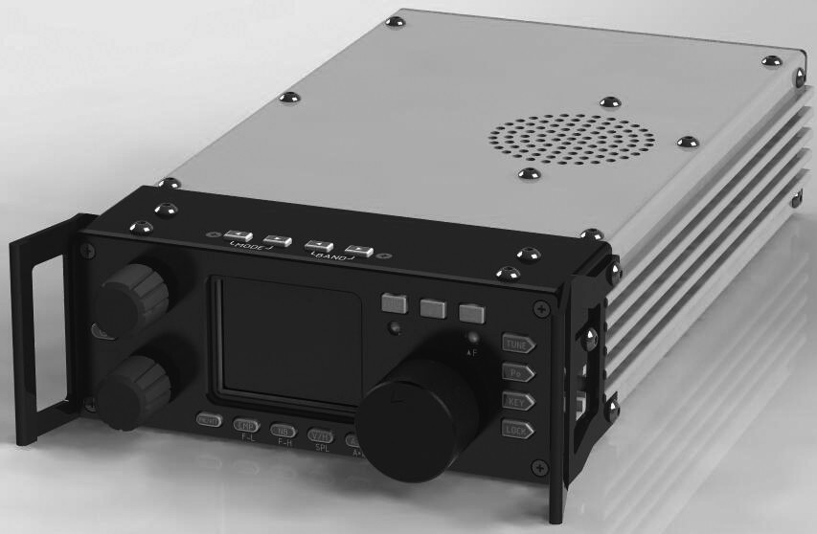

A 24-bit data size @48kHz sampling rate, it has excellent transmit performance and highly configurable functionality; following these outlined steps:

* High performance front end narrowband ESC preselector;
* Covers the frequency range of 0.5~30MHz;
* SSB/CW/AM/ FM* 1.8 inch high brightness color TFT LCD screen;
* ±24k bandwidth spectrum display and waterfall display;
* Software defined narrowband filter(CW mode: down to 50Hz);
* Detachable display unit;
* Up to 20W of RF power (selectable);
* Built-in wide range automatic antenna tuner;

5

* Various I/O interfaces including the baseband I/Q output to allow it to interface with any external device that can handle baseband I/Q, including sound card-based or PC-based applications such as XDT1.

In order to better understand how to use this device, please read this entire manual carefully before use to fully understand the operation of the G90.

* FM Operation The FM mode can only be turned on when the GSOC controller is used with the G-90.

**2 Control Layout & Explanation**

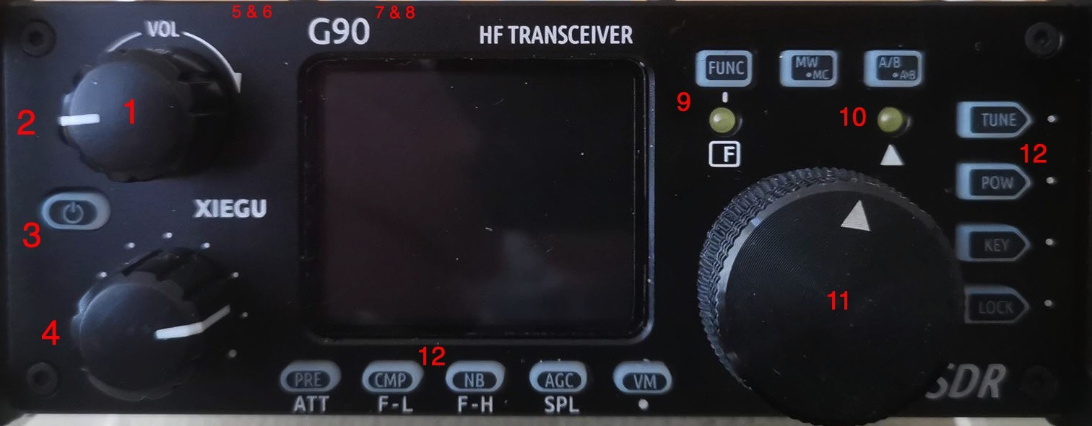

1. Volume knob

Turning + /– the volume.

Short press: Switch to headphone output mode.

1. Power/ Receive or transmitting status pilot lamp

Standby / receive status shows as yellow-green; transmitting status shows as red

1. Power switch

In the off state，momentarily press it to boot. In the on state, press and hold it to shut down.

1. Multifunction adjustment Knob

In default mode, turning this knob will step the **VFO** by 100 kHz. Default assignment may be changed in User Define Settings.

Press and hold this knob to switch to the Select Custom function.

5～6 Mode switching Mode switching

Will switch the mode of operation

7

7～8 BAND Switching

Switches between usable bands

1. Function LED

This pilot will light when the second function of the button is operated.

1. △ F Pilot

Lights to show secondary button function is possible at this time

1. Main Knob Operating frequency.

This knob will change the current frequency by 10, 100, 1k or 10k depending on the User Selected amount

1. Function buttons

Button definitions and 2nd functions are detailed in the Quick Buttons Operation Section.

## Head Unit Connections

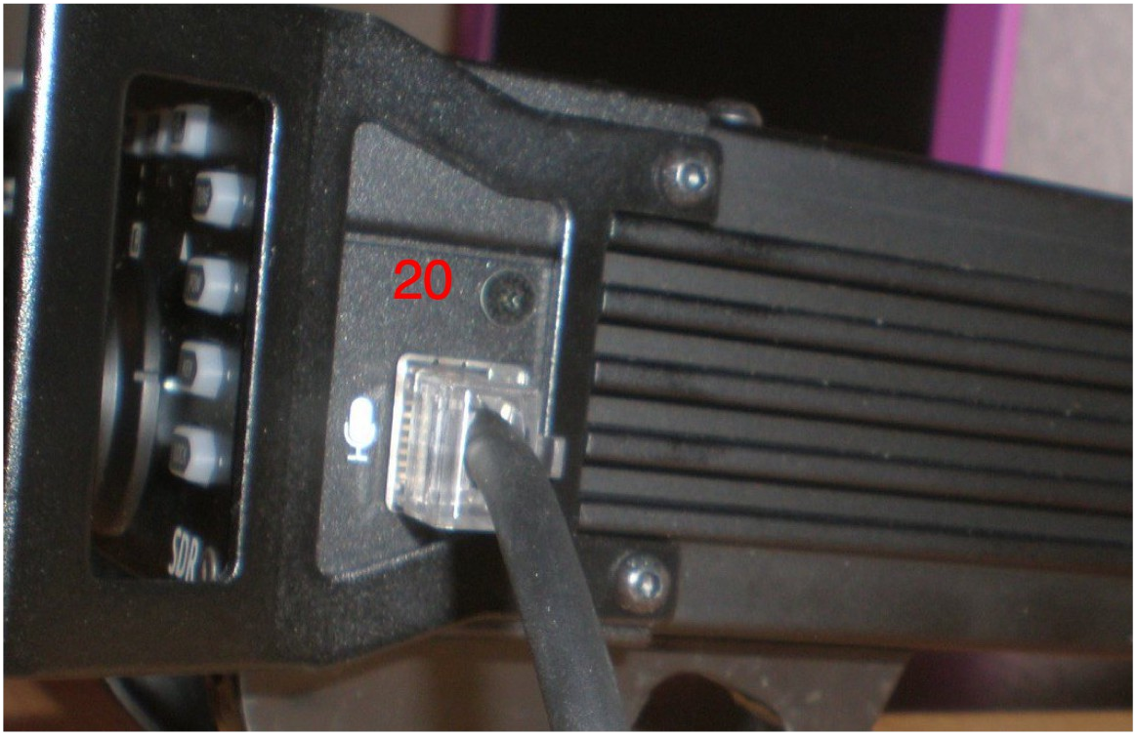

1. **MIC Interface**（On the right side of the machine connecting the multi-function MIC to this connector).

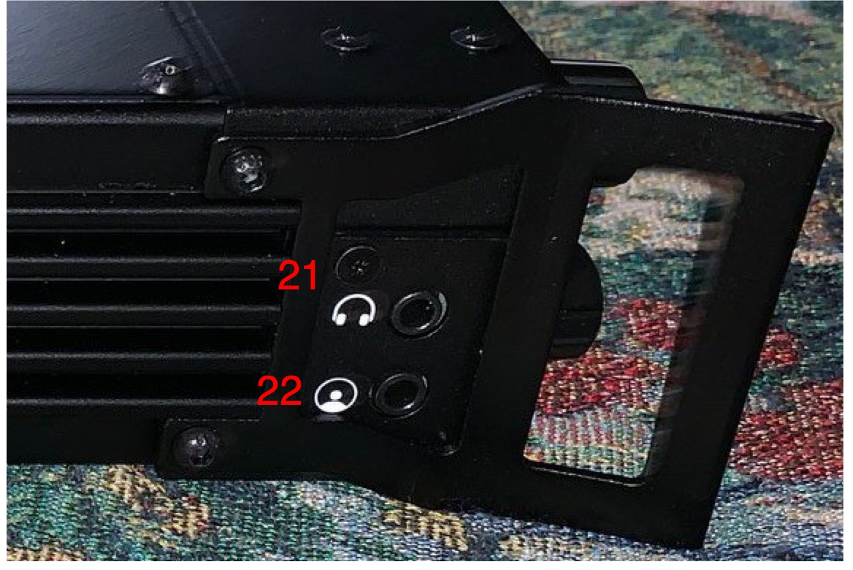

1. **Headphone jack**（On the left side of the Control head）

This 3.5mm stereo jack (3-pin) is for connecting stereo only headphones.

1. **Xiegu communication interface** （On the left side of the machine-head）

9

## Unit Rear Connections

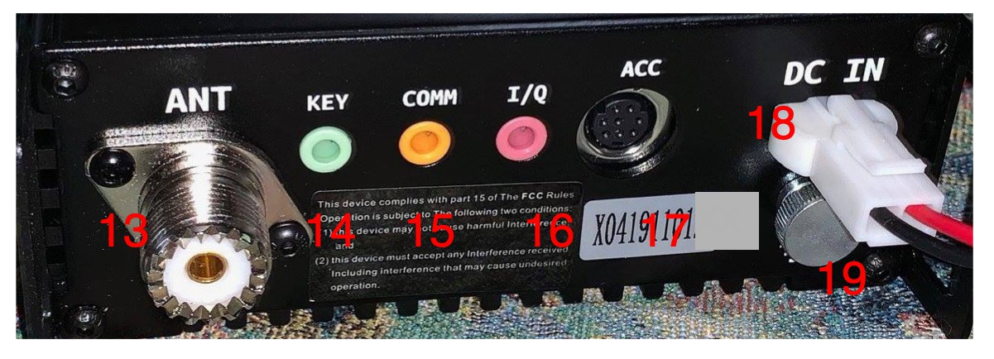

1. **Antenna interface** 50 ohm SL16-K type (SO-239)
2. KEYER interface

The interface is a 3.5mm stereo jack for connection to manual/automatic telegraph keys. See **Keyer** diagram in Wiring.

Straight telegraph keys - must have the dit and dah connected together (the tip & ring).

1. COMM interface

Used for the base Unit firmware updates.

1. I/Q Signal output

The interface is a 3.5mm stereo jack for “I/Q” signal output.

1. ACC Connector

The interface is an 8-pin mini DIN interface, as defined in the Wiring.

1. DC power interface

External DC power input interface. The round hole is "-", the square hole is "+" 13.8 v.

1. **External Ground terminal -** attach to station ground.

## Quick Buttons Operation

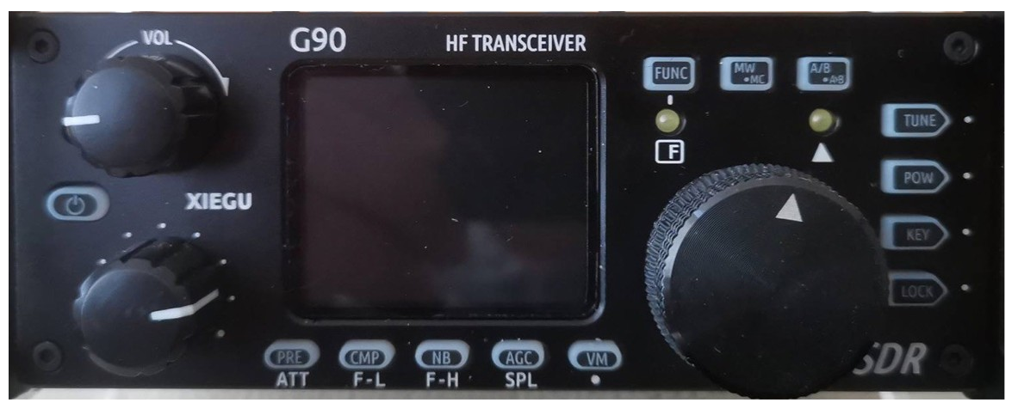

Turn on/off Transceiver

Turn on：press button. Turn off：from the on state， Long Press



Turn off screen:

In the power on state, tap the On/Off Button to turn off the screen display. The other functions still work. Pressing any button or turning the Main Knob will wake up the screen display.

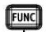Function Button

Pushing **Function Button** allows the use of the 2nd functions (hidden functions) of controls.

MW/MC 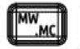

**Memory Write – Memory Clear** allows storage of all current

parameters into memories

A/B A<B 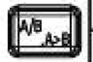

**VFO** split mode and copy A into B button

11

Pre / Att

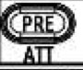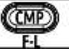

Choosing Preamplifier or Attenuation

**CMP – FiL** Microphone Compression and setting low edge of audio filter

NB – Fil H

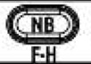Turns on noise blanker and setting high edge of audio filter

**AGC – SPL** Turn on/off AGC and select Split mode

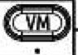**VM** VFO Memory button

Function Buttons – Tune, Power Out, Key, Lock

Usage of Function Buttons explained in Operation Section

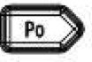

##### On the top edge of the head:

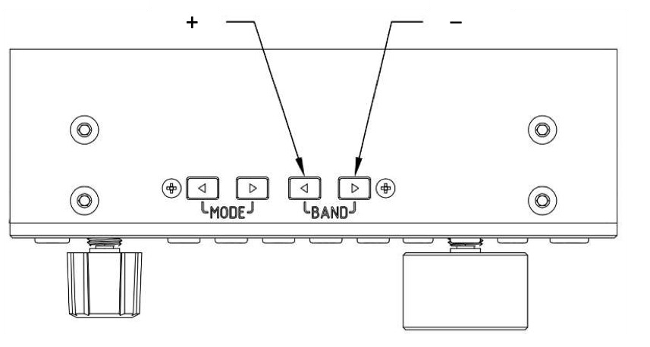Operating frequency band selection

Chooses the current band for operation

Operating Mode

Press a MODE button switches to next mode

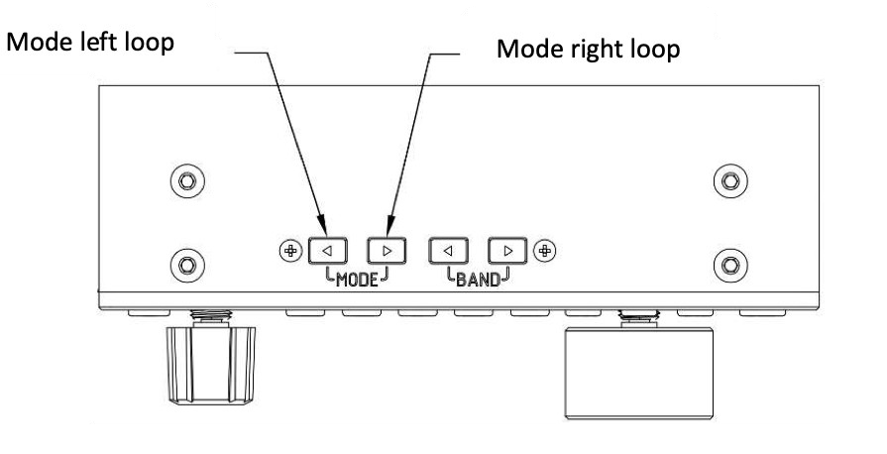

##### Further Switch and Button Functions

In addition there are switches on the shafts of the Volume Control, Multi-function Knob and the VFO (Main) Knob. These operate in **Short Pressed** and in **Long Press** mode.

|  |  |  |
| --- | --- | --- |
| Switch | Short Press | Long Press |
| Volume Control | Switches between Speaker and Earphones | VOX On and Off |
| MFK | Press for SQL mode | Select User Controllable Settings |
| VFO Main knob | Selects Frequency Steps,1,10,100 or 1K |  |

13

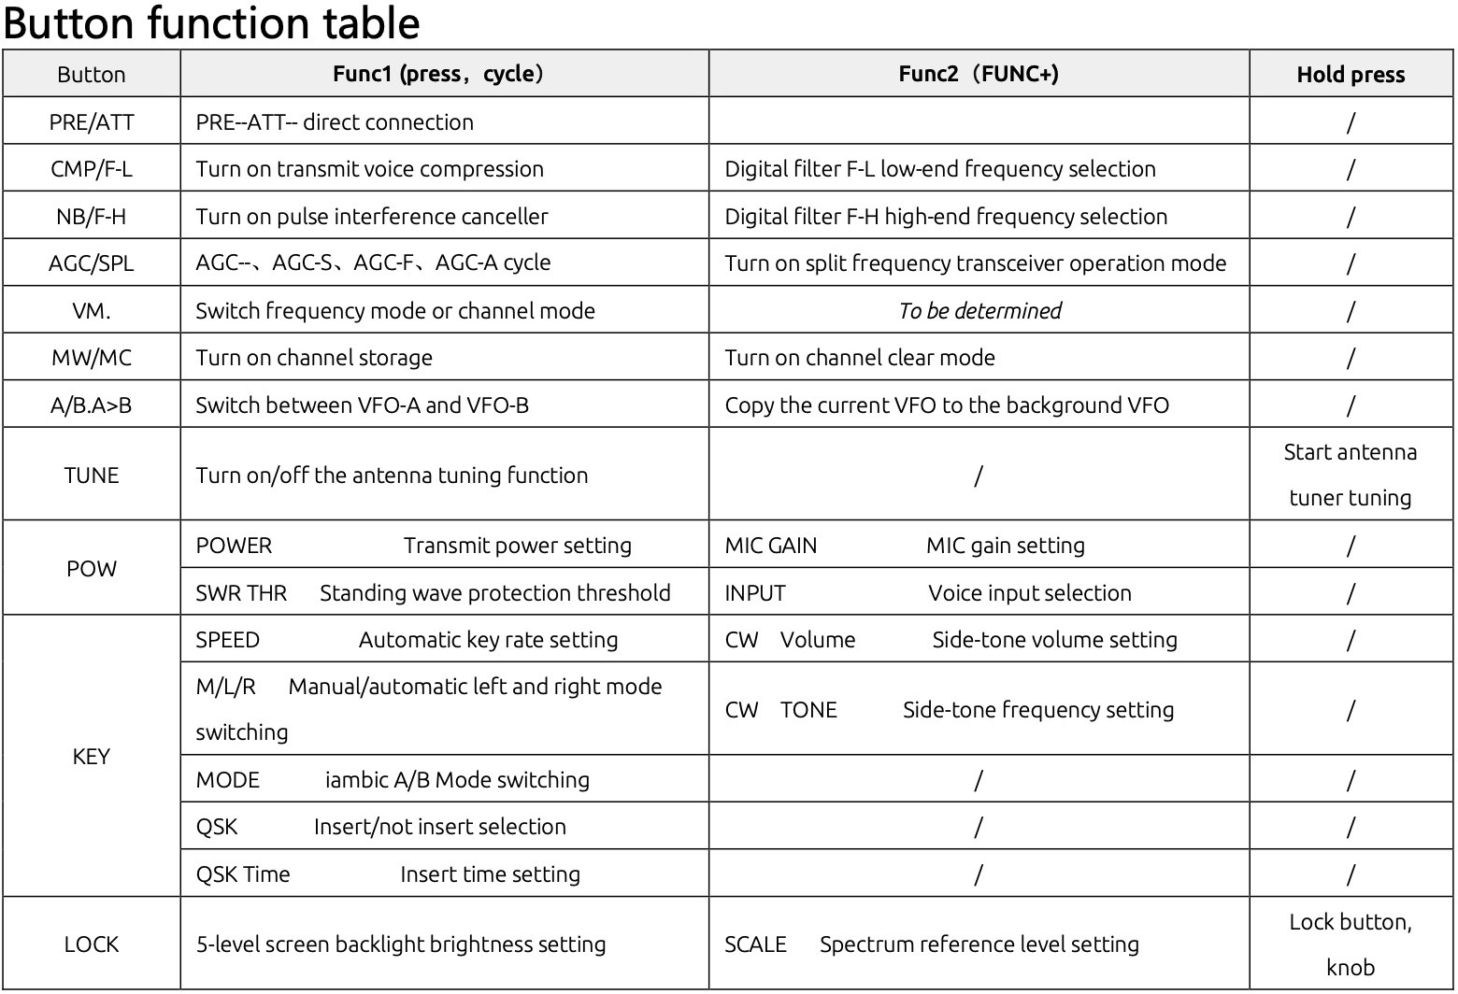

# 3 Operating the G-90 Controls

Power On/Off 

In the O**ff** state，momentarily press it to boot. In the **On**

state，press and hold it to shut down.

Volume Control 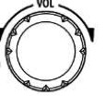

**Speaker mode**：Rotate the volume knob left or right to adjust the speaker output volume.

**Headphone mode**：**Short Press** the volume / headphone mode knob to activate the switch and enter headphone output

mode. Rotate the volume knob left or right to adjust the headset volume.

**VOX mode on / off**： Press and hold the volume knob for 3- second to turn the VOX feature on or off.

When using the AF in/out Port of the ACC interface, set the relevant volume in the system menu not the Volume Control.

## Operating frequency band selection

The G90's frequency range covers 0.5 to 30 MHz. Amateur frequencies within this range are divided into multiple bands, and band switching can be performed in a number of different ways.

Operation method:

Press the BAND’s < or > button，Switch to the next or previous operating band separately.

15

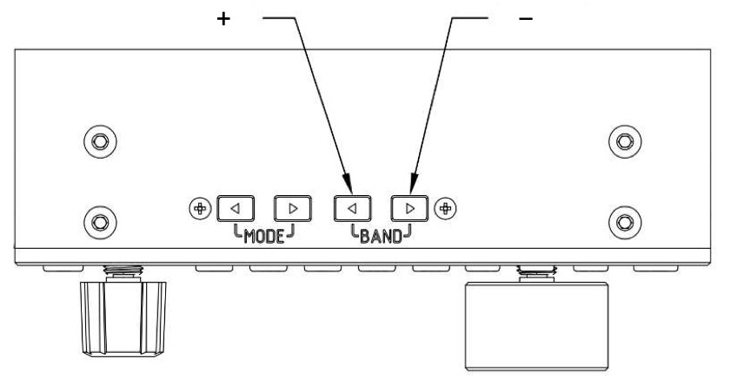

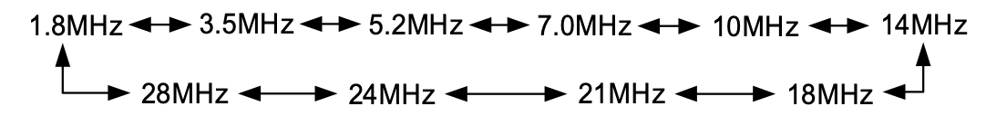

* + - Each amateur band has a **user-defined frequency** that can be used temporarily, when the band is switched, you will see this custom band as a second band option. This can be confusing.
    - Whether the 60-meter band is usable depends on the laws of different countries (or regions).
    - Different versions of the machine have different frequency settings depending on the laws of that country (or regions).
    - VFO-A and VFO-B are two independent VFO modes that can be set to different operating frequencies and states. Check [VFO Settings] please.

### Set the operating frequency

There are two ways to set the G90 operating frequency, first is to use the main knob (1hz thru 10Khz) and multi-function handle (100khz) to set the frequency.

Operating method 1：

Set the frequency using the main knob **Main Knob**

Short press the main knob, select **10 Hz, 100Hz,1kHz or 10kHz**

step. **100KHz** on **MFK** if defined.

Rotate the main knob to set the frequency using the current step.

Operating Method 2:

Set the frequency using the Microphone

Press the [F-INP ENT] button on the handle, G90 enter the frequency setting state, the cursor will blink in the first position on the left side of the frequency display bit;  Enter the frequency values you want to set, and then press the [F- INP ENT] button again to complete the frequency setting.

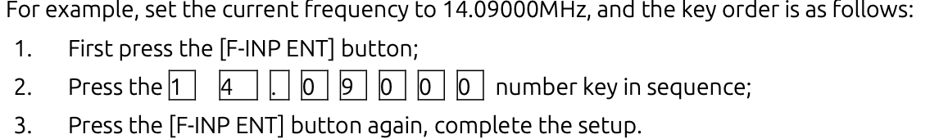

Operating mode select

Pressing [ MODE < - > ] button，will change the mode according to the following fixed order switching.

17

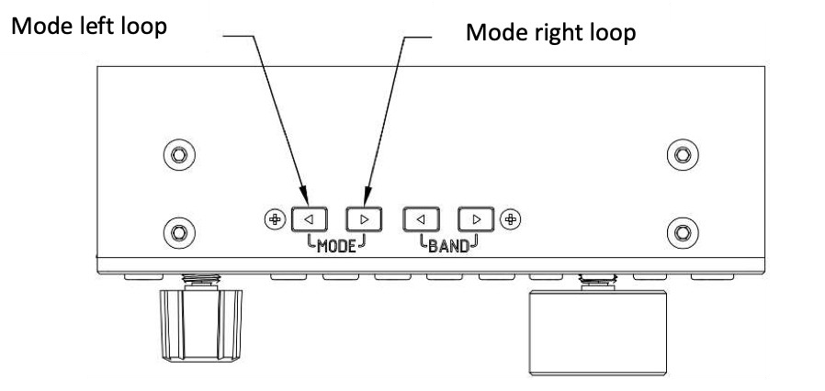

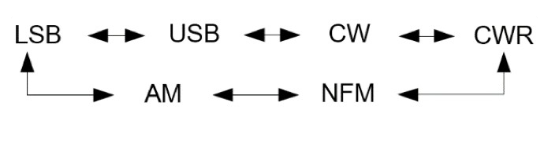

The FM mode can only be turned on when used with the GSOC controller.

## Multi-function Knob Operation

**Default:** Steps by 100 kHz frequency bits.

Change Multi-function Knob operation via 2nd Feature use (without Function button press):

**Short press:** Enter SQL item to adjust SQL noise depth. 2nd short press to exit SQL.

**Long press**：To go to the **User Custom Feature**

menu, then rotate the **main knob** to select the

appropriate 2nd function: **FFT scale**, **Freq Step 100k**, **SQL level**, **PO level** or **Key speed** and assign to the **MFK**, and short press the “CMP”

key to Save the setting and ensure that the feature is selected. At this point, the feature is saved to the **multifunction adjustment knob,** turning the **MFK** will change the selected setting.

To exit the **Long Press** press the **AGC** button 

## Adjust Transmitting Power Out

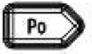Operation method：

* + - Short press the [Po] butt to enter the power setting state, the right side of the screen function display area will display the power settings number.

Rotate **Main Knob** for power setting with stepping of 1W PO, press

**Main Knob** to save.

19

When using the G90 transceiver for the first time without knowing the current antenna state, minimize the set transmit power value before **Tuning**

When the **User Custom Feature** of the **Multifunction Knob** is set to Power Out, turning the **MFK** will change Power out directly. Otherwise **Po** and **VFO** knob set power out

## Split VFO Mode

There are two independent VFOs inside the G90 transceiver. We can set different frequencies and modes separately. With the SPL function, it is convenient to realize the split transceiver operation.

To Selelct VFO

1、 Press the [A/B / A>B] button to switch VFO operation between VFO-A and VFO-B.

2、 When switching to a certain VFO state, you can set

the current VFO's operating frequency, mode and other settings as needed.

##### Split frequency transceiver SPL operation method:

1、 Set the **receiving frequency** and mode (**VFO-A**) first;

2、 Then set the **transmit frequency** and mode (**VFO- B**)

3 、 Press Function Button so function lamp is on, of then Press [AGC/SPL] button. Press Function button to

begin Split Mode of transmission

4、 Turning on the SPL function to turns on the split transceiver mode.

You can make full use of VFOA/B to set different frequencies or modes, and switch between two frequency points in real time.

You may store this functionality into any Channel Memory, making SPL operation on a desired band very easy to access.

## Automatic Antenna Tuning Unit (ATU) Operation

**This G90 is integrated with an efficient automatic antenna tuner that can help you quickly set up and debug your antenna.**

Before attempting to transmit or TUNE on any band, minimize the Power Output to prevent damage to the unit

**Short press the [TUNE] button, the unit will be connected to the built- in antenna tuner and the "TUNE" logo will appear at the top of the screen.**

21

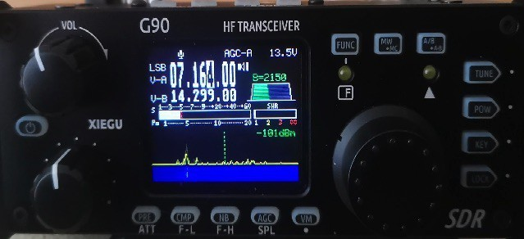

**Next press the [TUNE] button again for 1 seconds and the ATU auto- tuning function will be activated. The unit will automatically return to receive status when tuning is complete.**

##### Note：

1. Press the [TUNE] button and the antenna icon appears at the top of the screen to indicate that the automatic antenna tuner function is turned on. You just turned on the automatic Antenna tuner but tuning has not been started.
2. To use the built-in automatic antenna tuner, you must press tune again.
3. If you start the transmission after pressing [TUNE] once, the “SWR” icon will appear on the top of the screen and flash, which means the standing wave of the current antenna is not tuned yet and needs to be retuned.
4. When the antenna tunes to the current band, be sure to turn off the Automatic Antenna tuner feature by pressing [TUNE].
5. When using a whip antenna and turning on the built-in antenna tuner for tuning, it is possible to cause strong RF interference to the unit or nearby electronic devices.

### Scanning SWR

G90 host has an antenna standing wave scanning function, which can scan the standing wave parameters of the current

antenna, and is convenient for the user to adjust the antenna.。Operation method ：

1、 **Long Press** the [Po] button to start the standing wave scan;

2、 After the scan is completed, the scanning process is

automatically exited or you may **Press** [VM] button to stop the scan

23

# 4 Microphone Usage

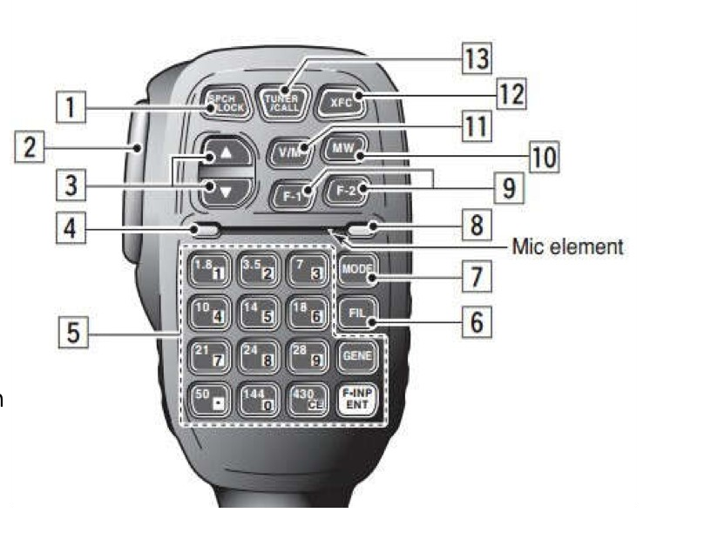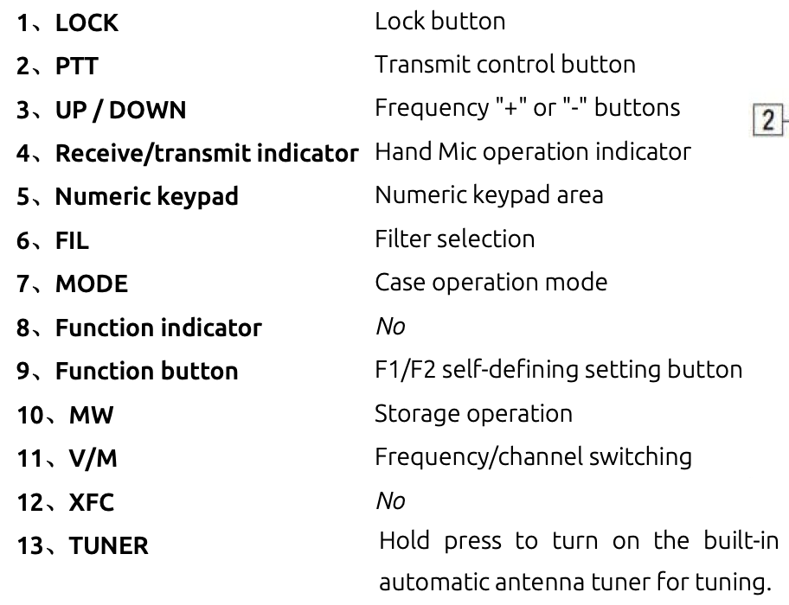

**F- input Ent** Allows direct entry of frequency

## 4.1 Using the Microphone to Control the Unit

Use of the microphone to control the unit is similar to other manufacturer's operation.

Enter the Frequency of Operation Press **F-INP ENT**

Direct enter the digits of the frequency:

0 7 . 1 0 0 0 0

Press **F-INP ENT** to exit and save the frequency Select the [MODE] of transmission

Press the MODE button and observe the MODE on the screen

Continue until desired Mode is selected

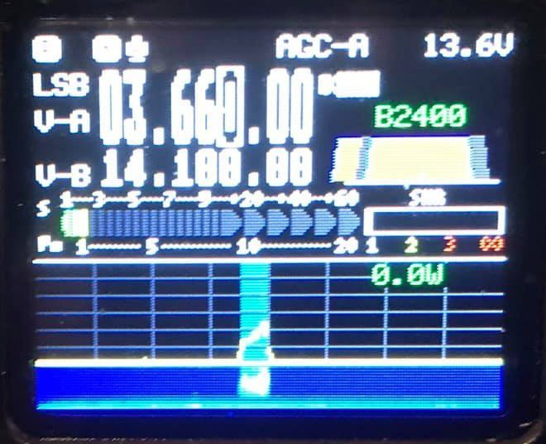

Select Filter and adjust Filter setting if desired (see **Adjusting Filter**)

Press the [TUNER] button and observe that the display indicates Tuning Operation is enable. Press Tune again and observe the display shows an active Tuning is being performed. Press Tune to STOP the tuning and press Tune again to unselect the Tune engine.

25

Press [LOCK] to lock the microphone buttons and PTT to engage Transmission

# 5 Operating Mode

## Set up for CW Mode

Operate with a hand key, paddles or an external keyer / controller device.

Insert the key plug (three-wire) stereo plug into the KEY interface; see **Wiring**

Press the **MODE** button to switch the mode to CW (or CWR);

Press the **KEY** button function to scroll through Speed, M/L/R for manual or Left or Right **Dah** preference for paddle, Iambic A or B, **QSK [ OFF will allow radio to operate as a code practice oscillator],** QSK Time (delay between End of Key Press and RX on), Ratio for dit/dah spacing (3 is standard).

**2nd Menu** (Press **Function Key - lamp is ON**):

CW Volume and CW Tone - side tone on successive press VFO Knob selects value

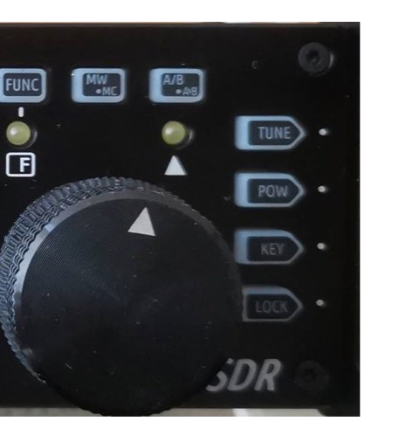

Press **Function** to exit 2nd Menu Press **Key** to exit Keyer Menu

**Long Press of CW enables CW decode.**

See **Adjusting CW Filte**r in **Adjustments**

**You can use the G90 as a CW code trainer:**

**The operation method is as follows: In the [KEY] button function, the QSK function can be turned off. In this state, when the *keyer* is pressed, the transceiver has a CW side tone, but *Does Not* emit RF.**

27

If you find your unit is not Transmitting, **CHECK** the **QSK**

Setting. QSK must be **ON to transmit**

Set CW or CW-R mode with **Mode** buttons Set CW send speed using **Key** button press Set Straight key (M) or Left or Right Dah Set Iambic A or B

Set QSK delay – 0 is no delay, RX between sent elements In 2nd Menu set CW Volume

In 2nd Menu set CW Side Tone

### Adjust Bandwidth

The B (Bandwidth) value is the difference between the Low and High filter settings. The Bandwidth display does not show correctly in USB mode but works the same.

We want the Low Filter setting lower than the CW side tone setting. So if you set 700 Hz in the side tone and you want a Bandwidth of 500hz, set the Low Filter to 450 Hz. Set the High Filter to 950 Hz. The displayed bandwidth will be 500 Hz centered on 700 Hz. When receiving signals in CW, the CW indicator will light between 450 Hz and 950 Hz. In addition CW will be decoded when Decode is on and the signal is within the bandwidth. Delta lamp lights when within the CW bandwidth.

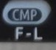To adjust the Lower bandwidth value, Press Function button and ensure Function lamp is on. Now Press the Fil – L

The Filter display will show L = and a value, this is the Low filter setting. Change it using the **Main Knob.** Press the Function button to exit.

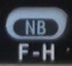Next Press Function and where the Filter display now shows H= and a value. Adjust this value using the **Main Knob**. Press Function button to exit.

With a narrow CW filter remember to tune in 100 Hz steps to avoid over stepping stations.

## Operating SSB Communication

Set **LSB** or **USB** for the Band using **Mode** buttons Plug the Microphone into the Microphone jack.

Use only the provided Xiegu microphone to prevent damage to you rig.

### Set the Receiver bandwidth

Bandwidth Adjustment

The B (Bandwidth) value is the difference between the Low and High filter settings.

To adjust the Lower bandwidth value, Press Function button and ensure Function lamp is on. Now Press the Fil – L

The Filter display will show L = and a value, this is the Low filter setting. Change it using the **Main Knob.** Press the Function button to exit.

Next Press Function and where the Filter display now shows H= and a value. Adjust this value using the **Main Knob**. Press Function button to exit.

SSB bandwidth for voice communications should be > than

2.4 Khz.

29

### To Enable VOX

Press the Function button, press the volume button to turn VOX on and off.

It is advisable to Press the **LOCK** button to lock the functions selected so an inadvertent button press Does Not change the set parameters

* 1. **To Enter and Recall Memory Channels**

Enter settings into Channel Memory

* + 1. In VFO mode, adjust to the required frequency, mode, advanced function status and other parameters;
    2. Press the [ MW/MC ] button to start the channel storage operation;
    3. Rotate the main knob to select the **channel number** to be stored, and **short press** the **MW button** to complete the channel storage;
    4. If the current channel has stored information, using this channel number for storage again will clear the previous channel information and save the current channel information.

**Bring up the storage channel:**

1、 If you press the [VM] button on the panel in VFO mode, you will enter channel mode;

2、 Rotate the main knob to switch the current channel.

**Clearing channel storage:**

1. In the channel mode, operate the second function of the [MW/MC] button to start the channel clear function;
2. At this point, the channel number starts to flash. Rotate the main knob to the corresponding channel number and press the main knob to complete the channel clear.

##### To Write stored Channel info to VFO

1. Press VM and use the VFO knob to choose the desire ChannelMemory
2. Write the Channel information to VFO A, Press Function button
3. Next Press A/B button
4. Press Function button – off, then Press VM to exit Channel mode.
   1. **Using Secondary (System) Menu**

Available parameters are:

Mic - define buttons: up/dn, F1 button, F2 button. LCD brightness level set - BL%

**Aux in Vol.** For I & Q volume from computer **Aux out Vol.** For I &Q output volume to computer Version (Display only)

Long press the FUNC button to enter 2nd System Menu

Short press VM button for next menu item or short Press PRE button to go to previous function.

Turn Main Knob to set function parameter or mic button function. Short press CMP button to save and exit.

Short press AGC button to exit without saving.

31

* 1. **Operating Digital Modes**

The G-90 is designed to provide I / Q output, via Line In and Line Out on the ACC port. To ensure correct communication with the computer attached, the signals must be of significant strength.

The I & Q on the **I / Q j**ack are on a Stereo Jack and you must plug a stereo connector into this and into the computer's STEREO input jack.

Failing to have a Stereo input on the computer means No I/Q input should be attempted, damage will occur to the G-90. A USB dongle with Stereo input should be used instead on the computer.

There must be Proper shielding on the cable this limits the noise passed in on the I & Q signals.

**Operating method**：

* + 1. In the system menu, using ACC port line input, select: AUX LINE IN. Set the appropriate input volume.
    2. In the system menu, select: AUX AFOUT VOLUM to set the appropriate output volume.

The G90 transceiver can be connected to a computer to perform various data communication with the corresponding computer software.

**Digital connections:**

Connect the computer audio output/input to the G90 from the ACC port (MINI-DIN8).

Insert the data cable into the COMM port, connect the G90 to the computer, and ensure that the computer driver of the data cable is installed correctly. The PC software can control the G90 transceiver; Adjust the volume of G90 and the input/output volume of ACC port to the appropriate values. Observe

the software interface to avoid the Audio frequency amplitude being too large and unable to communicate.

Select the corresponding working mode to perform data communication.

In order to prevent interference, the radio and computer must be well grounded. Please install the EMC magnetic ring for the data cable and audio cable, and install it as close as possible to the radio.

The G90 uses the standard CIV instruction set. You can use the standard instructions in this instruction set to remotely control the transceiver. You can also use the CIV instructions oft other software to control the G90.

Check the G-90 forum for current digital setup information and help. <https://www.facebook.com/groups/578581345625251/?ref=group_header>

33

**6 Wiring**

The G90 can use a 13.8V external DC power supply. The DC power supply has a current load capacity of at least 10A. The supplied power cord can be used to connect radio and DC power.

When connecting the DC power supply, please carefully connect according to the following figure to avoid reverse polarity of the power supply.

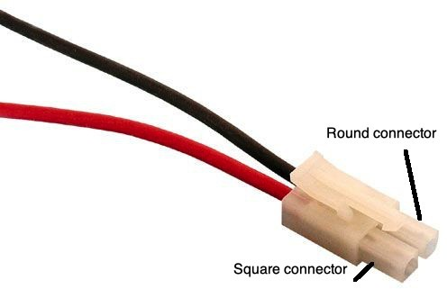

The red wire is connected to the positive pole (Square connector) of the power supply, and the black wire is connected to the negative pole of the power supply (Round Connector).

**Warning: Connecting the power connections in the reverse order can Severely Damage your radio!**

When using an external DC power supply, you must prevent external interference from entering the radio through the power line or that the radio frequency is radiated outside through the power line, we can put an EMC magnetic ring (not supplied) on the power line. Install the magnetic ring as close as possible to the radio.

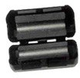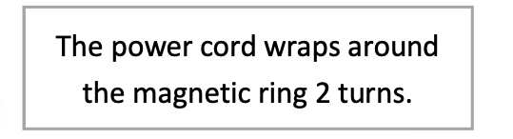

When using an external power supply, carefully check the polarity of the power cord and do not reverse the polarity.

The limited warranty of this radio does not include damage caused by an external power connection error or damage caused by improper power supply voltage.

##### 6.1 Connector Wiring Diagrams

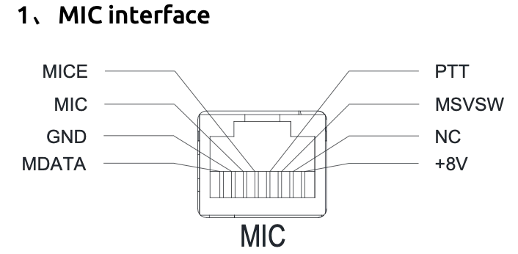

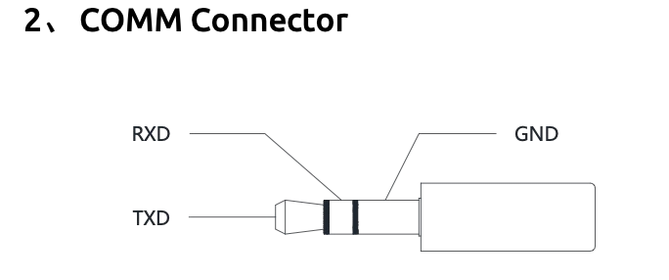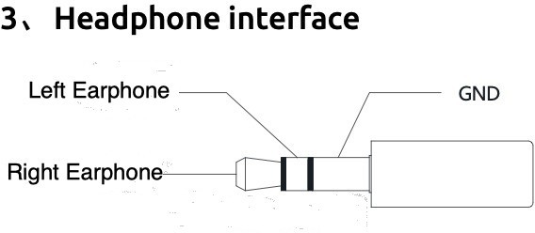

35

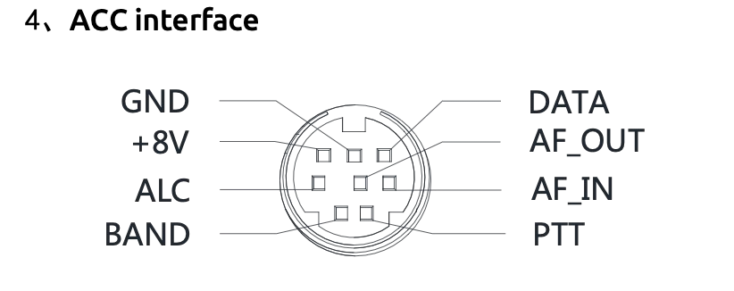

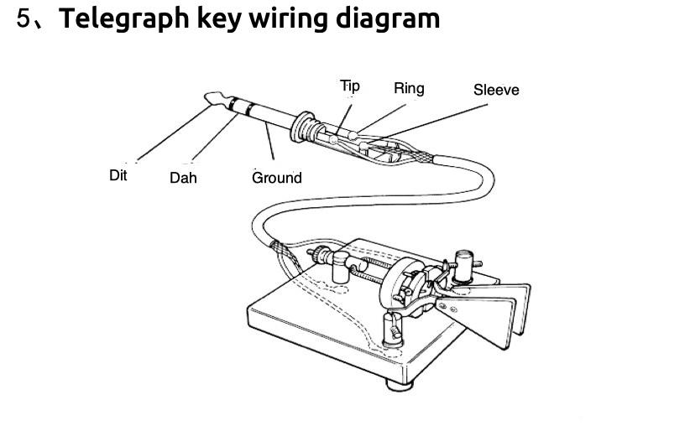

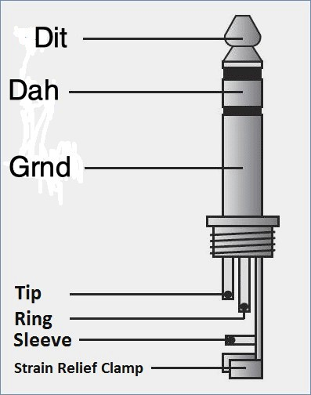

**7 Firmware**

Firmware update instructions Update date: 2011.04.26 Version 1.6 on the G-90 Head and Body

Header firmware: G90_DispUnit_FW_V1d06_buid001 Host firmware: G90_MainUnit_FW_V1d06_build002

Release Notes:

This version of the firmware cannot be mixed with the previous versions. Both the head and the host must be updated to latest version. **1.6**

Features & Menu:

1. Added CW decoding interface Operational logic:

Long press KEY button to switch "CW decoding" / "waterfall image" display interface

1. Added cw zeroing frequency alignment indicator LED with triangle icon is the alignment indicator

CW decoding function will not work properly when the received CW zero frequency and the locally set CW Side Tone differ greatly.

1. Modified SPLT logic, greatly reducing the delay of switching between different frequency transceivers
2. The software variable bandwidth filter icon and operation logic are changed to show a bandwidth ramp icon
   1. FL key adjustment filter low end (filter icon left) cutoff frequency
   2. FH key adjustment filter high end (filter icon right side) cutoff frequency

37

* 1. A small arrow appears above the filter icon when adjusting FL/FH to indicate the currently adjustable item.
  2. When adjusting FL/FH, the low-end frequency and high-end frequency of the current filter will be displayed in the FFT display area, and the width in the frequency domain will be represented.

1. The S/PO indication on the display is changed to a block- filled style, and the four colors of green, red, yellow, and dark gray indicate different states.

Color description:

Dark gray: background color Green: Receive signal ≤ S10 or transmit power ≤ 9W Red: Receive signal > S10 or transmit power > 9W Yellow: peak hold value

1. FUNC function adjustment: Press the FUNC key to switch the first/second function of all buttons. When the second function is selected, the FUNC LED lights up, otherwise it is off.

Exit FUNC and close FUNC LED when the main knob is pressed

1. Adjusted the volume control step, from 18 to 28, and each step is smaller. This more closely mimics an audio taper Volume Control.

8, fixed the CW side tone adjustment problem.

9. Optimized the structure and improved operational efficiency. Bug fixes:

1. Fixed the problem that the switch and the hand microphone PTT could not exit after being pressed at the same time.
2. Correct the problem that the background VFO frequency is incorrect when entering the SPLT mode.
   1. **G90 Firmware Update Instructions**

The following items are needed:

* + 1. USB-to-Serial cable
    2. G90
    3. A computer running windows(XP/Vista/7/8/10)operation system
    4. A 12~15VDC(current ability not less than 5A)power supply

1. Install USB-to-Serial cable:

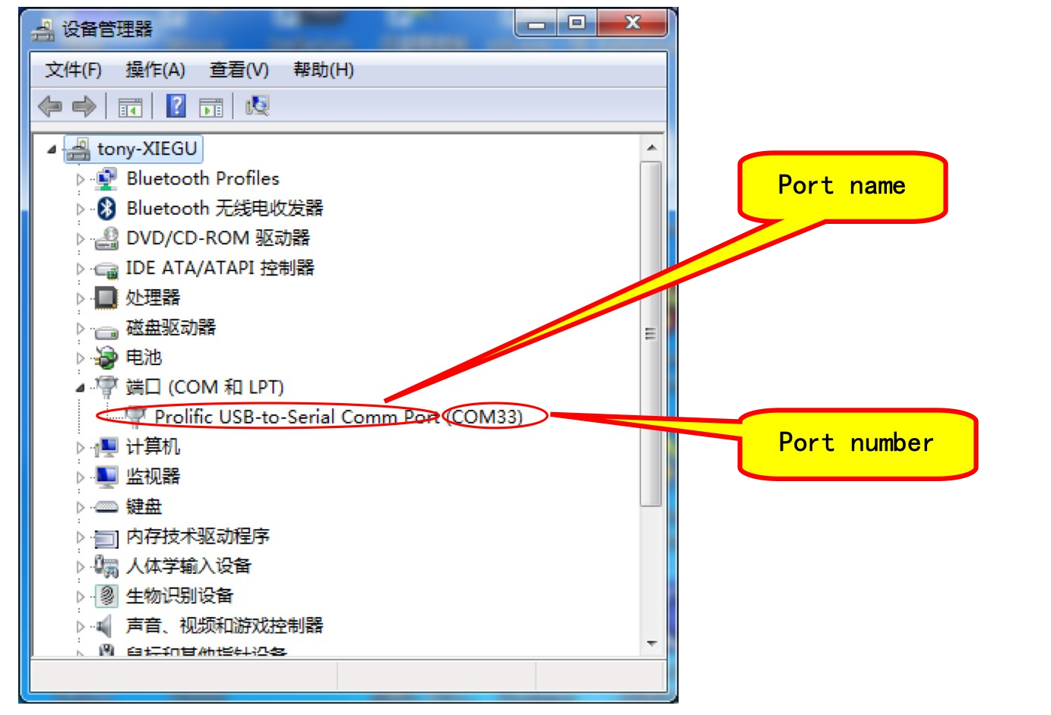The very first thing is to make sure that the USB-to-Serial cable is working properly on the computer. After the cable is plugged into the USB port of the computer, the operating system will prompt to find the new hardware, and then the operating system will automatically install the driver of the new hardware. If all goes well, we can see the virtual serial port in the device manager of the computer. If the driver can’t be automatically installed by the operation system then we need to install it manually (driver files can be found in the update pack).

After that, we can see the virtual serial port and its port number (which in my computer is COM33) in the device manager.

39

1. Wiring everything up:

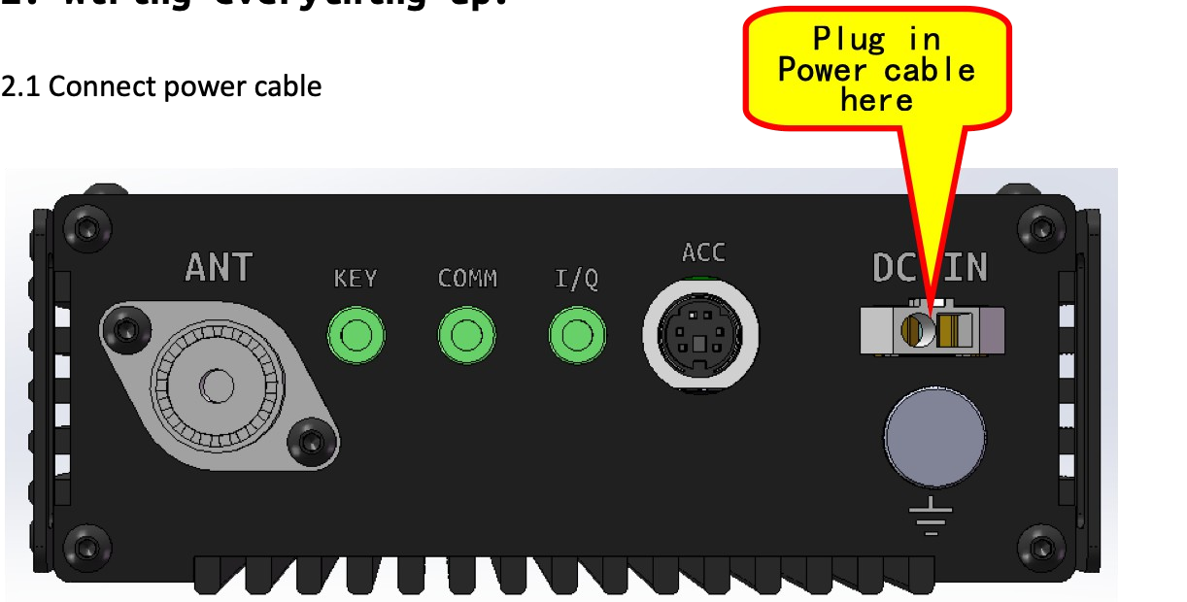

Plug in Power cable here

* 1. 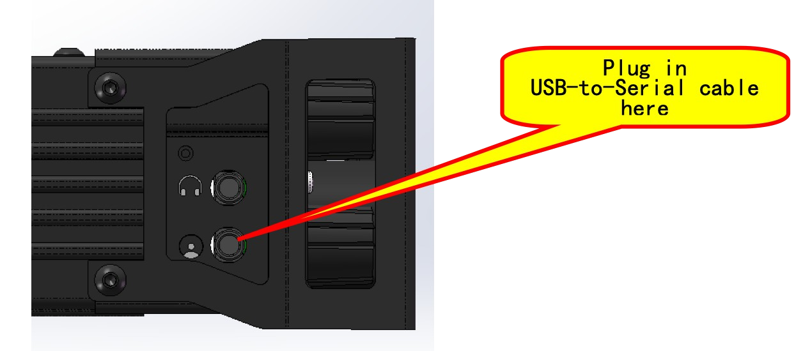For Head updating:

Plug in USB-to-Serial cable here

* 1. For Base updating:

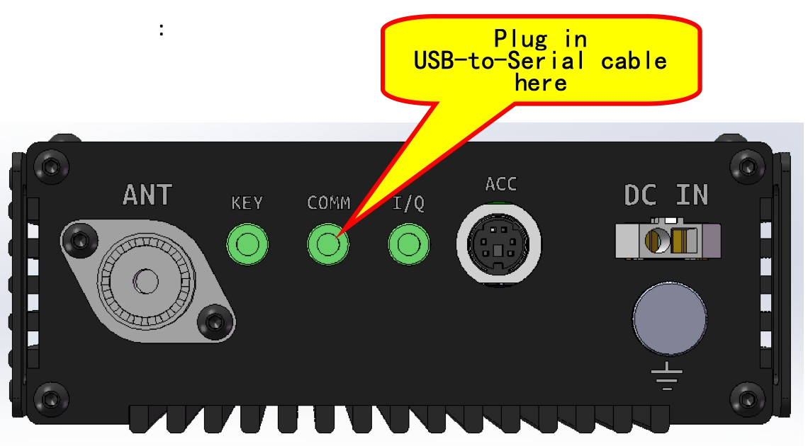

These instructions are exactly the same for the Base Unit and the Head Unit. There is NO NEED to separate them to update the firmware.

The Base Unit is Updated 1st via these instructions. Then the Head Unit is Updated. Both units must be Updated and have the same version number.

1. Update firmware via hyper terminal software: TeraTerm 4.96 is contained in the Xiegu ZIP file available for downloading.
   1. Configuration of TeraTerm4.96

**41**

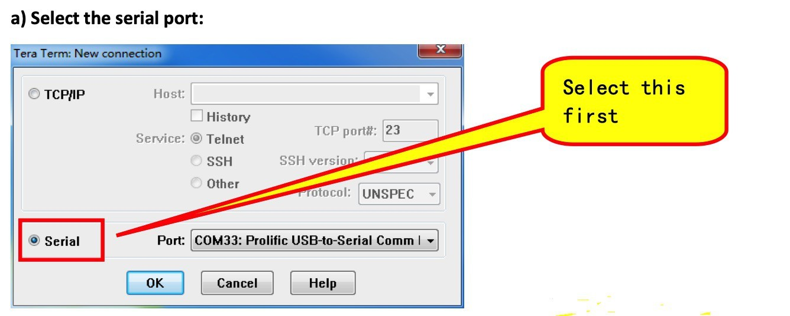

Select this first

1. 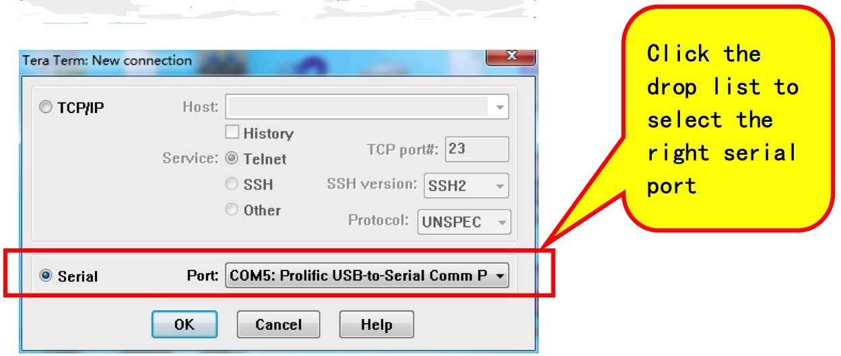Select serial port:

Click the drop down list to select the right serial port Select the baud rate:

Click Baud rate drop down list and select **115200** & Click OK

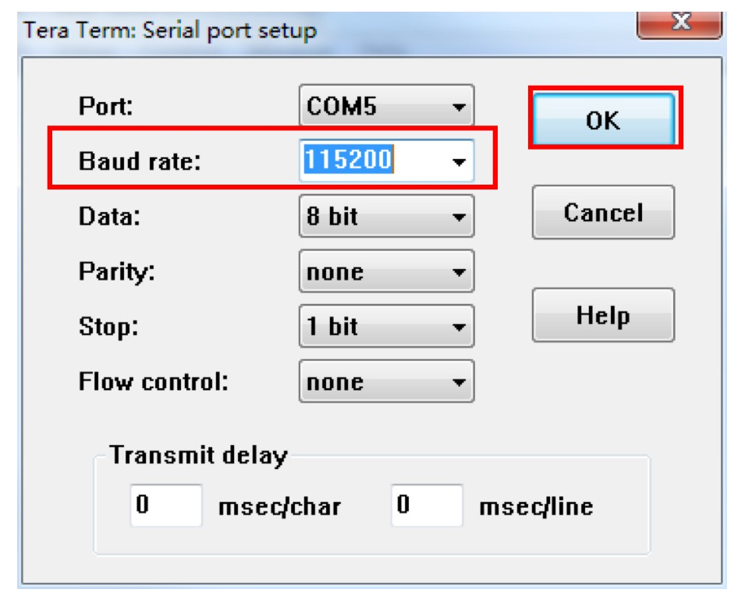

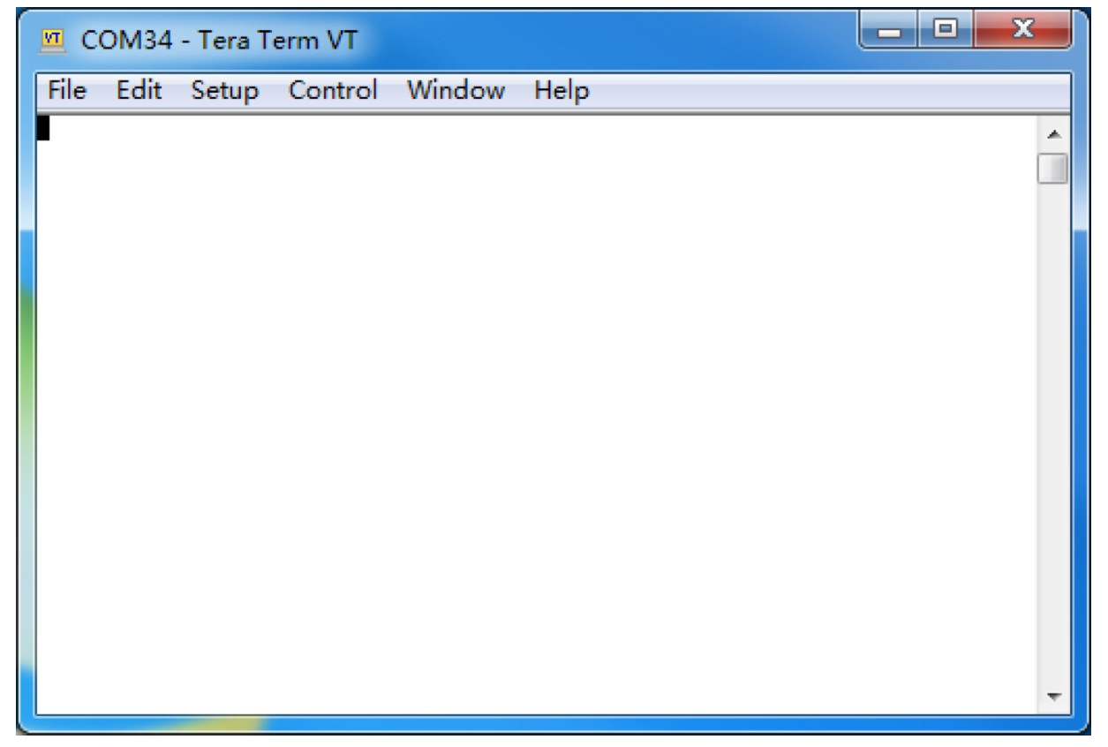The main workspace:

* 1. 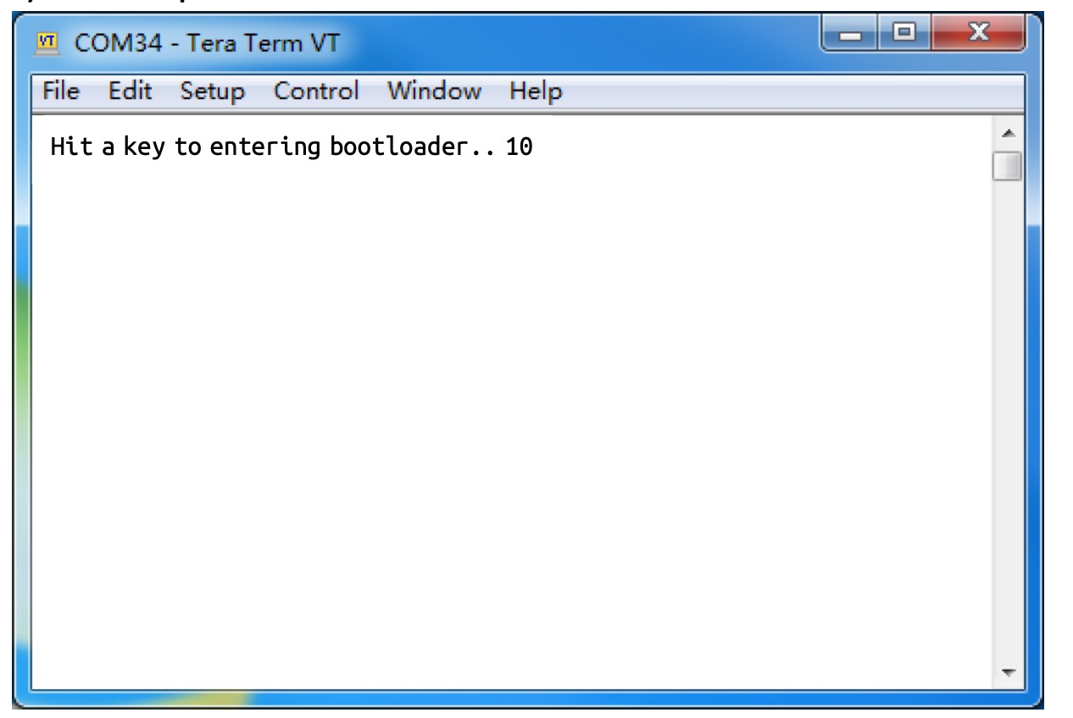Press G90’s power on button:

Press SPACE bar IMMEDIATELY on the computer to interrupt the booting procedure. There is a countdown timer att he end of string, press SPACE bar before time out. IT IS NOT 10 Secs. More like 5.

* 1. The updating menu:

43

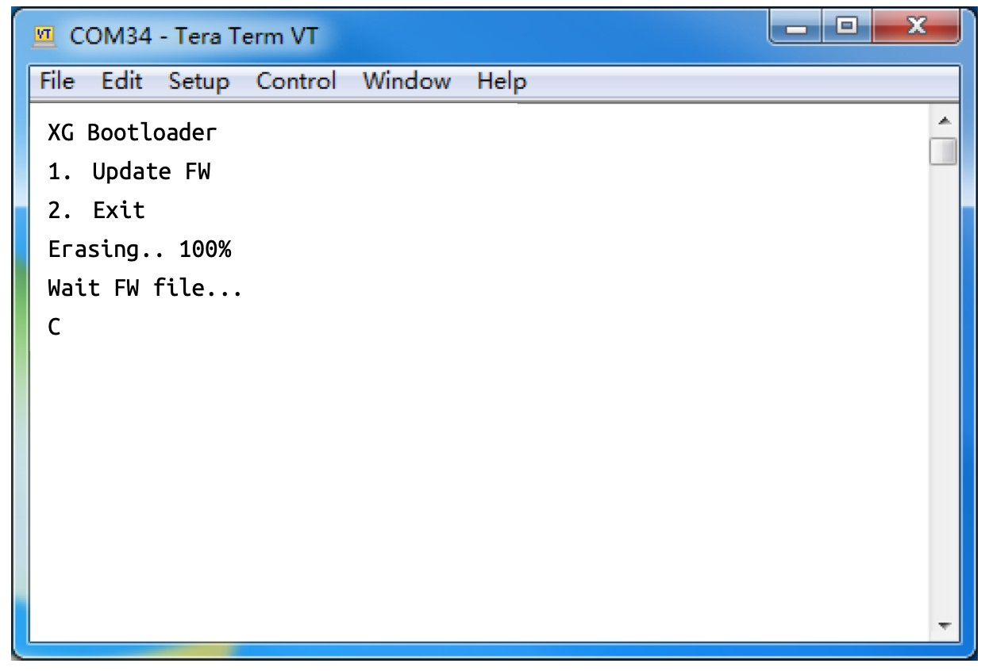

XG Bootloader

1. Update FW
2. Exit Erasing.. 100% Wait FW file... C

Step1: Press 1 to see the display shown

Step2: Wait until “Erasing.. 100%” is displayed and then “Waiting for FW file...”

* 1. Select the firmware file:

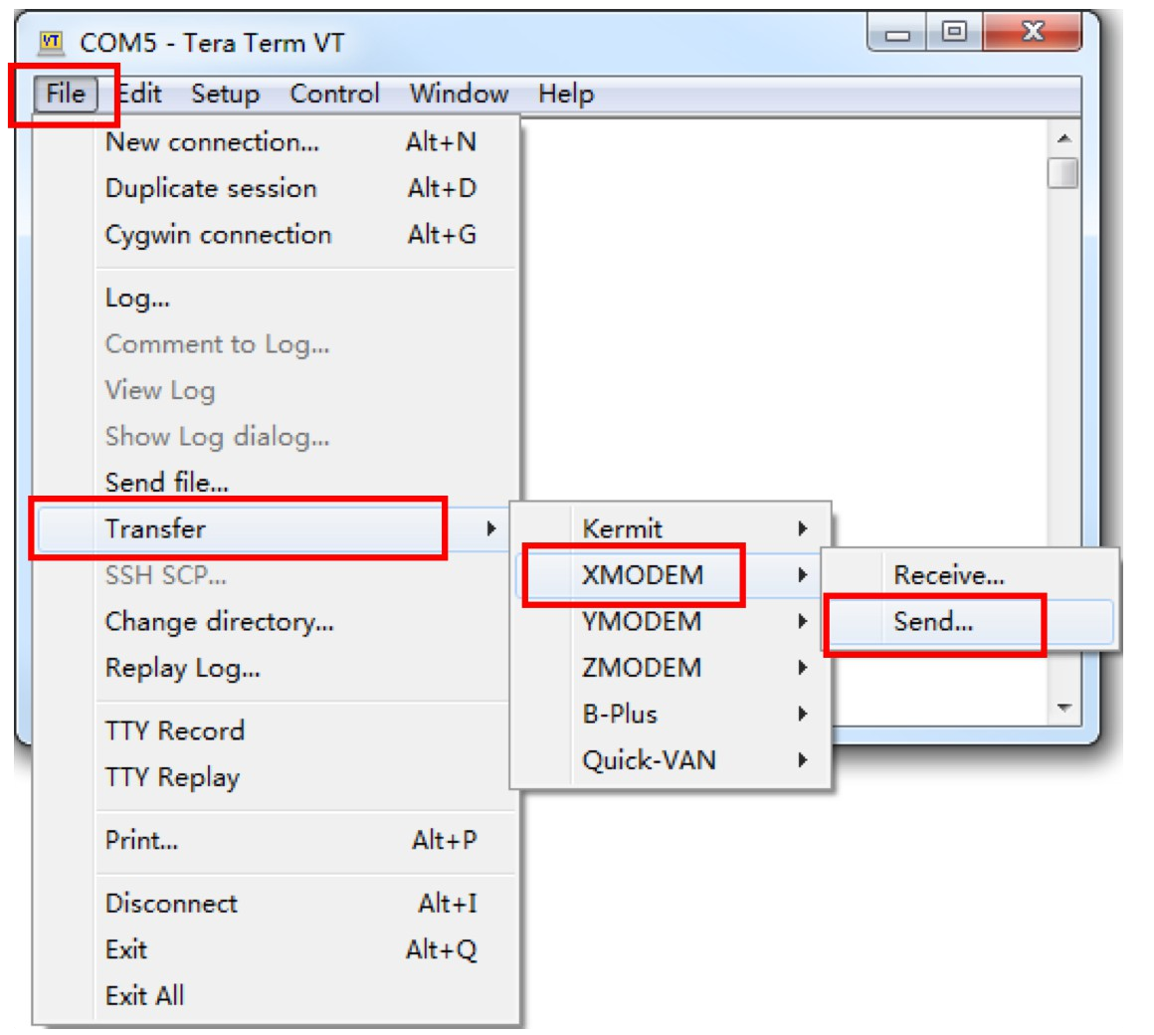

Click File#Transfer#XMODEM#Send…

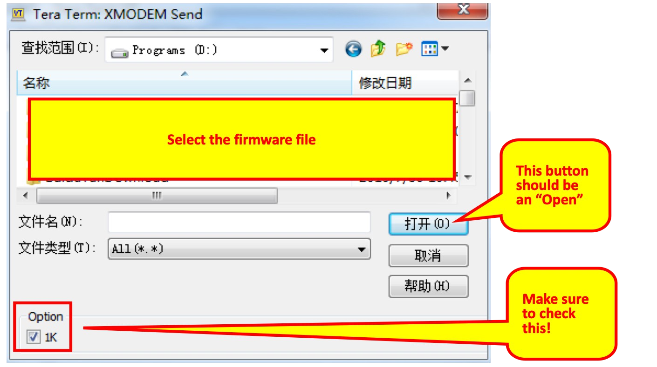

Click the 1K Option – failure to do so will give a Communication error on G-90 display after Up Date

45

Browse and select the firmware file, and click the “Open” button.

* 1. Transfer start
  2. Wait transfer finish and reset the G90

If this was the Body Update then Proceed to Update the Head Unit.

--End-of-instruction--

**8 Errata**

* 1. **Boot interface call sign setting CSN**

The G90 can set the call sign information displayed on the boot interface under the Xiegu Logo.

Operating method：

* + 1. Long Press the [**VM**] button to go to the [**CALL SIGN**] function and the call sign editor.
    2. Select and enter characters under the editor, using the **VFO** knob after editing the call sign, save the set text using the **VM** button to save and return to the normal operation state. Use the **NB** button to erase a character.
    3. When you turn it on again, the boot interface will display the call sign you edited under the Xiegu Logo.

47

**Addendum**

**Basic SETUP G90 CAT Control for Windows HAM Software**

General information about CAT

CAT is an abbreviation for ***Computer Aided Transceiver*** and describes the way to operate your rig via a serial protocol in sync with your PC.

There are numerous ways to connect your rig to the PC e.g. via RS232, via ACC port or via USB, but in all cases you have to emulate the serial connection for the protocol, which is used by the vendor.

Xiegu uses the protocol spec from ICOM, also known as CI-V (Computer Inferface Five). The complete spec of ICOMs CI-V can be found when you google it, e.g. here: <http://www.plicht.de/ekki/civ/civ-p0a.html>

To control the XIEGU rigs you can use the **IC-7000** or **IC-718** as the device in different ham radio software. Which one works best depends on the implemented software design, the following screen shots are best practice and work in general.

Xiegu only has implemented a subset of the functionality of the CI-V protocol, but this is actually not documented. So the only method is trial and error along with other Ham operators knowledge

Remember to replace the COM Port in the screenshots with the configured port in your environment!

Recommended procedures

*Omnirig* [*http://www.dxatlas.com/OmniRig/*](http://www.dxatlas.com/OmniRig/)

*Omnirig* works as middleware between ham software and the CI-V protocol and supports various transceivers.

You have to install and configure Omnirig first and choose it as the transceiver in your dedicated ham software. Omnrig is very stable and fast and a good choice for an interface between your software and.the G-90.

Please be aware to configure 2 Stop bits in Omnirig, that differs from the most other implementations.

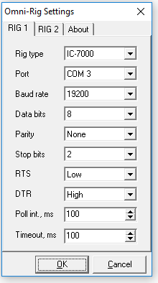

Recommended procedures

When you are using Omnirig, there are many programs (like WSJT-X or fldigi) which displays Omnirig in the dropdown list for transceivers and it should be used instead of the real emulated transceiver (so use Omnirig instead of IC-7000 as an example).

*Ham Radio Deluxe Rig Control*

HRD Rig Control works best with the settings in the screenshot below. Depending on your XIEGU rig it could be necessary to set the flow control with activating DTR or RTS.

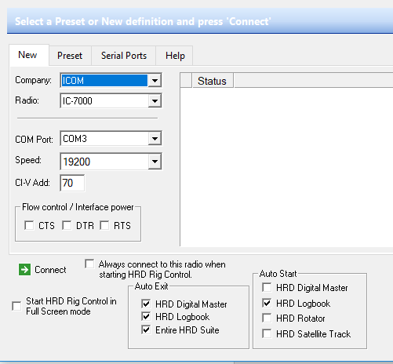

When you are using HRD, there are a lot of other programs (like WSJT-X or fldigi) which then uses HRD directly in the dropdown list for transceivers instead of the real emulated transceiver (so use HRD instead of IC-7000 as example)

Recommended procedures

*WSJT-X with HRD CAT Control*

As mentioned before you can use WSJT-X with HRD or Omnirig as the RIG in the dropdown box. There is also the possibility to drive WSJT-X direct by choosing IC-7000 or IC-718.

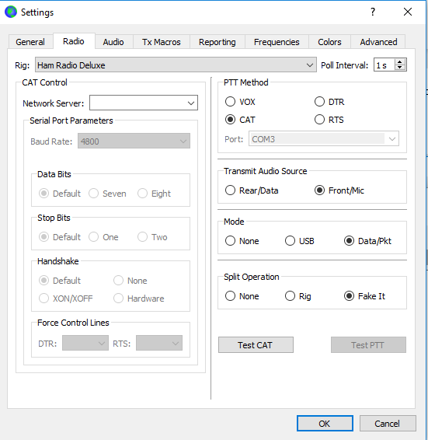

##### WSJT-X with Omnirig CAT Control

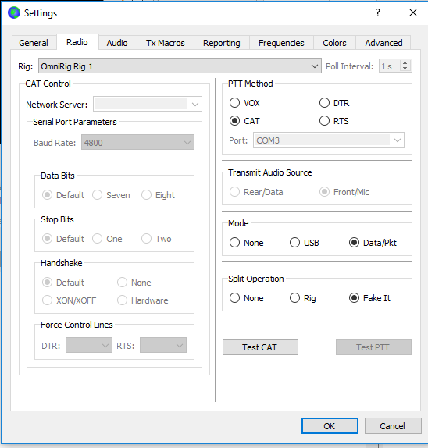

Recommended procedures

*FLRIG direct CAT Control IC-718*

Because FLRIG is open source, you are able to control your rig without license fees. You can find flrig, fldigi and the other fl programs at *SourceForge* <https://sourceforge.net/projects/fldigi/files/>.

FLRIG works best when using the IC-718 emulation as transceiver.

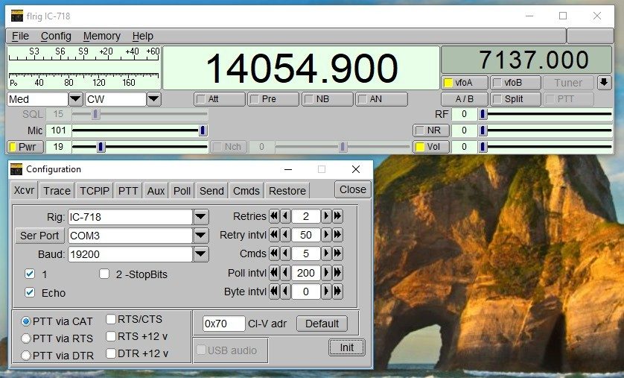

Recommended procedures

*N1MM+ Logger*

If you want to use a contest logger like N1MM+ you can also define IC-7000 as emulated transceiver. The recommended settings you can find on the screenshot below.

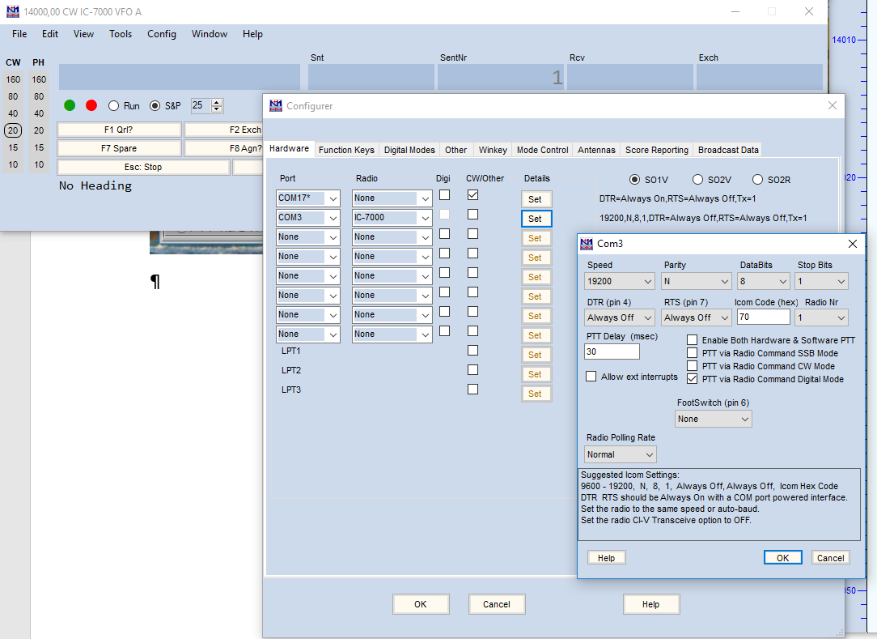

Please feel free to add your own experience with other software programs or other Os like UNIX and OS-X.